**Diary entry #1** By Zakaria Ahmed

Team – Zakaria Ahmed, Joshua Baker, Sienna Jenkins

**Game Premise**

All of the students were allocated into teams and given a briefing of a game to be made and presented. It was that to make an employability board game: relating to different skills that employers look for.

**How the game is played**

The game is intended for 3-8 players in which it is entirely round based. At the start of every round, all players add a topic to the sorting box. 2 players pick a random topic out of the sorting box, then are given a minute each to discuss why other players should pick their topic. Then all other players are to vote on their choice of speaker. Game plays again with 2 different people, finishes when everyone has played their turn. Player with the most overall votes win.

**Rules**

To start, all players input a topic into the sorting box, 2 players pick a topic each from the box and set them aside, the players are then to speak on chosen topics. 2 minutes are given to speak whilst an additional 30 seconds are for the other players to decide who to cast a vote on (note – they can only cast a vote once per round). During discussion time, only the 2 speakers may speak. Votes are counted and the same rules are recalled with 2 different peoples. The game finishes when everyone has spoken and at this point votes are counted, the winner having the most votes.

**Materials used**

For the sorting box feature, it was decided that players picking would have to pick from chance, so a third-party website was used to simulate probability via a wheel spin

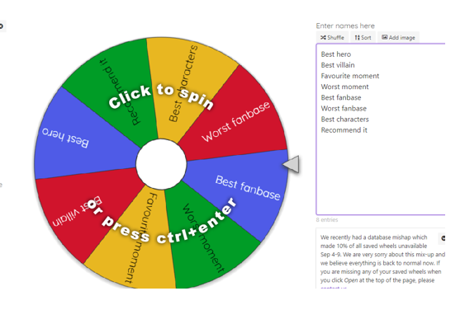

B

A

**Picture 1 – “A” represents the wheel spinning and would pick a topic that lands on the arrow. “B” is the list of topics that users would input into.**

Other materials used: timer, pen and paper to count player score

**Play testing**

Although no play testing was done, feedback was given. The game idea was fun and challenging, another group noted that the rules were easy to follow, this was because of the simplicity of the rules and the round based system so most players can pick up the rules of the game. On the other hand, there was difficulty in how the game portrayed the employability aspect that the briefing mentioned. The lack of time prevented a detailed explanation of how the game related to skills and employers and given more time, this would be fixed in later development stages.

**Teamwork**

The time in teams was great as there was many ideas circulating that all could discuss and problems were solved together. An example of this was trying to think of a title for the game. Collectively, the name was thought of quickly without wasting much time and would have resulted in a game with no title if there was no team to help with the naming process.

**Employability skills**

Key employability skills would be teamwork and communication. None of this would have been possible if it were not for the joint effort of having a team and communicating with each other allows a team to evaluate the development of creating a game to ensure it all flows smoothly.

The importance of teamwork is also apparent in employability as it prevents individuals that are stuck on problems since there are more people to help. Thus, creating an encouraging environment that encourages work to be done.

In retrospect, teamwork in this session was apparent and it has proved to have worked well, learning to work together would improve on the development of creating games.